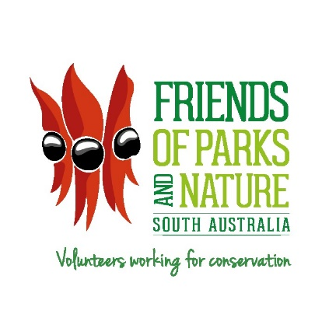

Park Operations and Community Nature Partnerships
National Parks and Wildlife Service
Volunteer Programs and Community Partnerships Unit
GPO Box 1047
Adelaide SA 5001
Australia
Ph: +61 8 8115 5629
www.environment.sa.gov.au
email: pamela.smith@sa.gov.au

FRIENDS OF PARKS AND NATURE INC. MEMBER GROUPS
- APPLICATION FOR GOLD PASS
TO: Mrs Pam Smith, Admin Officer, Friends of Parks and Nature,
Volunteer Programs and Community Partnerships Unit
GPO Box 1047, ADELAIDE SA 5001 pamela.smith@sa.gov.au

APPLICANT DETAILS

NAME OF VOLUNTEER: Mr/Mrs/Ms/Miss …………………………………………………….

ADDRESS: …….……………………..…………………………………………….

.…………………………………………POST CODE ………….…..

TELEPHONE: ………………………………………………………………………….

EMAIL: ……………………………………………..…………………………...

FRIENDS GROUP/S: ……………………………………………………….…………………

DATE JOINED A FRIENDS GROUP: ………………………………………………………….

SIGNATURE: ……………………………………………………………….

FRIENDS GROUP ENDORSEMENT

I confirm that the above person has been an active member of the above-mentioned Friends Group/s for a minimum of fifteen (15) years.

NAME: ……………..……………………………………………………………………

ADDRESS: …………………………………………………………………………………..

……………………………………..…………………POST CODE ………...

TELEPHONE: …………………………………………………………………………………..

EMAIL: …………………………………………………………………………………..

FRIENDS GROUP: …………………………………………………………………………………..

POSITION IN FRIENDS GROUP e.g. Secretary, President …..………………………………….

SIGNATURE: ………………………………………………………………………………….

For Office Use Only: Does the member already have a Gold Pass ? YES/NO

