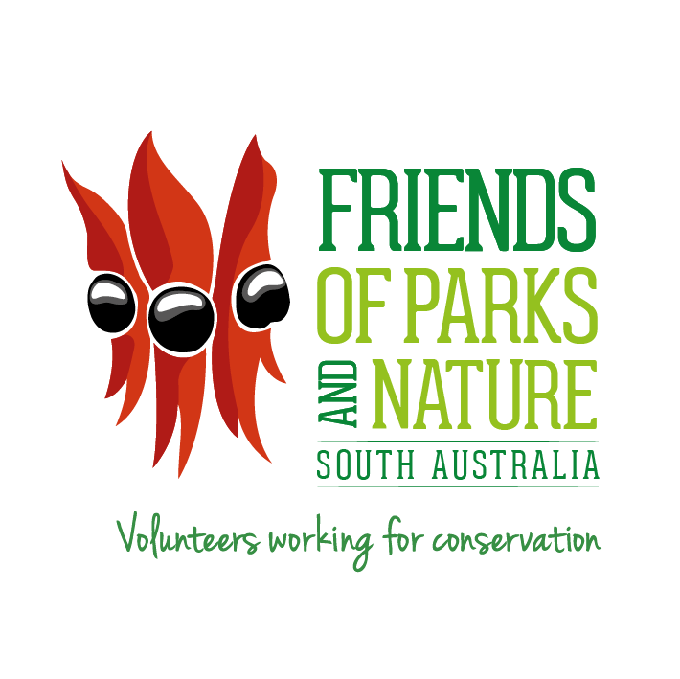
Mr Duncan MacKenzie OAM
4 Edinburgh Avenue, Stonyfell SA 5066
Telephone: 8332 1204
http://www.friendsofparkssa.org.au/home
ABN 32 457 858 155

Patrons: Dr. Barbara Hardy, AO, Mrs. Jean McLaren,
Hon. David Wotton AM, Mr Dene Cordes, PSM.

FRIENDS OF PARKS AND NATURE INC. GIFT FUND
The Friends of Parks and Nature Inc. Gift Fund supports volunteer efforts that protect and restore our parks and natural spaces. Registered on the Australian Government’s Register of Environmental Organisations, all donations are fully tax-deductible. In line with taxation rules, contributions cannot be directed to specific parks or projects—but your generosity helps fund vital work in biodiversity conservation, heritage restoration, and ecological recovery across the landscape.
FAQ’s

Making Donations to the Gift Fund
We welcome all contributions to the fund. All donations (excluding bequests) are tax-deductible and are accepted on the understanding that funds will be allocated at the discretion of the Friends of Parks and Nature Inc. Board, rather than directed by individual donors. This requirement is in accordance with the guidelines set by the Registrar of Environmental Organisations.

Who can donate?
Individuals or businesses who wish to support the work of Friends of Parks and Nature Volunteer Groups and the environmental and heritage conservation work they carry out across our National Parks and the broader landscape.

How can I donate?
Donations can be made payable to Friends of Parks and Nature Inc. Gift Fund, and sent to:
The Treasurer
Friends of Parks and Nature Gift Fund
C/- the Secretariat, Community and Nature Partnerships Branch
Department for Environment and Water
GPO Box 1047, Adelaide SA 5001
Email: DEWVolunteers@sa.gov.au
Please contact the Friends of Parks and Nature Inc. Secretary at DEWVolunteers.sa.gov.au if you have questions.

Is this donation tax deductible?
Yes and receipts are issued for tax purposes.
Who can apply for a grant from the Gift Fund?
All Friends of Parks and Nature member groups involved in conservation and restoration activities in National Parks can apply by submitting the application form attached below.

What types of projects or items can applications be submitted for?
The Gift Fund grant funding can be used for a range of equipment and activities to support the work of volunteer member groups in our Parks. For example:

- Equipment
  - Tools
  - Monitoring equipment

- Project costs
  - Technical support /planning costs
  - Tubestock, native plant seed, potting mix etc.

- Building skills, knowledge and awareness
  - Educational material/field guides
  - Interpretive signage and displays
  - Costs associated with running tours or field days
  - Costs associated with publicising the group, advertising etc.

How much can be applied for?
This is variable depending on the balance in the Gift Fund. Please contact DEWVolunteers@sa.gov.au for details.

When are applications due?
Applications for Gift Fund grants can be made at any time.
What reporting is required?
A financial acquittal and final report describing how the funds were used is required at the end of the project.

How are applications assessed?
The Friends of Parks and Nature Inc. Board has a sub-committee which will undertake an assessment of applications and recommend projects to the Board for approval.

If a project is successful, a written notification will be sent to the applicant group setting out the terms under which the grant will be provided.
Publicity / recognition of funding
A successful applicant must ensure that appropriate acknowledgment is given to the Friends of Parks and Nature Board Gift Fund as a funding source.

Where do applications need to be lodged?

Please contact DEWVolunteers@sa.gov.au for details on how to lodge an application.

Gift Fund Grant Application Form

1 PROJECT TITLE (< 10 words)
2 DETAILS OF APPLICANT
Group Name

Incorporation number (If applicable)

Australian Business Number (ABN)

Registered for GST (Y/N)

3 PROJECT CONTACTS
 | Contact person 1 | Contact person 2
Name:
Address:
Email:
Phone:

4 PROJECT DETAILS
Describe the proposed use of the funds, why it is important to the group, the number of volunteers to be engaged and the location of the project.

