DATE:
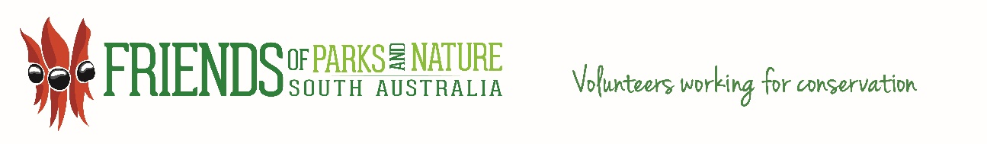
Friends of Parks and Nature Inc. Gift Fund DONATION FORM
ABN: 32 457 858 155
DONOR NAME:
OR
ORGANISATION NAME IF APPLICABLE:
ADDRESS:

EMAIL ADDRESS:

PHONE NUMBER:

Thank you for your generosity. Would you like to be acknowledged as a Donor? YES NO

Please note;- If your donation is tax deductible do you require a tax receipt? YES NO
(Donations to the value of $2 or greater are tax deductible).

Under the Australian Taxation requirements of a not for profit organisation, a ‘Friends of Parks and Nature Gift Fund Committee’ will consider the distribution of all tax deductable donations. The committee does not have to comply with donor directions.

General Donation to the Gift Fund – this provides support to the statewide member groups which conduct a large number of on-ground volunteer projects both on and off parks. | Amount $$
Post Bushfire Recovery Program – the 2020 bushfires devastated parts of South Australia, and in particular many National Parks bore the brunt of these wildfire. The impact upon the plants and animals of these very hot, intensive wildfires has been catastrophic for many species, and it will take decades for some parks to recover fully. Many Friends of Parks groups are at the front line of ensuring the parks recover as quickly as possible with seed collecting and propagation, habitat restoration and rehabilitation and weed control. | Amount $$
Osprey Recovery Program – Osprey coastal habitat has come under increasing pressure through development resulting in disturbance of their natural nesting sites. This program will create nesting platforms and sites for the eagles to use and establish a monitoring system through the use of satellite tracking, drones and monitoring cameras. | Amount $$
Wombat Conservation Program - The northern hairy-nosed wombat is in a population with only 300 individuals remaining and habitat loss is the single biggest contributing factor to this. The major loss of native vegetation is land clearing for a variety of purposes including new housing developments, industrial developments, more farmland and recreational purposes such as golf courses. ‘Wombats SA’ and other Friends groups work very hard at maintaining remaining habitat for wombats, in the mid north where the Hairy-nosed Wombats are still present, and in the South East where the Common Wombat is holding on in parks such as the Coorong National Park. These remaining habitats are critical for the species continued survival. | Amount $$
TOTAL DONATION AMOUNT | $

Please send this completed form to: contact@friendsofparkssa.org.au

Please send your donation electronically to:

Name of Account: Friends of Parks and Nature Inc.
BSB: 325 185
Account Number: 0362 0754
Bank: Beyond Bank

OR:

Mail your cheque to: Pamela Smith
Secretary, Friends of Parks and Nature Inc.
Volunteer Programs Unit NPWS SA
Department for Environment and Water
GPO Box 1047, Adelaide. SA 5001

